


Response to Request for Proposal
© 2025 YASH Technologies Middle East FZ LLC. Strictly private and confidential. No part of this document should be reproduced or distributed without the prior permission of YASH Technologies Middle East FZ LLC

Technical Proposal Response
HQ 2025-05 - CYBERSECURITY GOVERNANCE
Submission Date – 26th Nov, 2025
Submitted By | YASH Technologies Middle East FZ LLC
Client Partner | Srikanth Pattabi Raman
Phone Number | 971501136540
E-Mail | srikanth.raman@yash.com

Contents
1 Executive Summary 3
1.1 Introduction 3
1.2 MFO Objectives 3
1.3 YASH Understanding of MFO’s Requirements 3
1.4 YASH Solution Highlights 4
2 Scope of Engagement 5
2.1 In-Scope 5
2.2 Out of scope 5
2.3 Key Assumptions 5
2.4 Pre-requisites 5
3 Service Delivery Model 6
3.1 Project Team Structure 6
3.2 Approach and Methodology 7
4 Key Deliverables 9
4.1 Deliverables 9
5 Project Management and Governance 11
5.1 Project Governance and Reporting 11
5.2 Communication Process 11
5.3 Escalation Management 12
5.4 Change Management 12
6 Case Studies 13
6.1 Leading UK Railway Technology Provider 13
6.2 Leading Healthcare company 13
7 Indicative Profiles 15
8 Corporate Overview 17
8.1 YASH Overview and Relevant Capabilities 17
8.1.1 YASH Overview 17
8.1.2 YASH Global Footprint 18
8.1.3 Service Catalog 18
8.1.4 YASH Recognitions and Awards 19
8.1.5 Overview of Partnership and Alliances 19
8.2 Relevant Industry Certifications 20

Executive Summary

Introduction
YASH Technologies Middle East FZ LLC (YASH) is pleased to submit this proposal in response to the Multinational Force and Observers (MFO) Request for Proposal HQ2025 05 for the establishment of a Cybersecurity Governance Layer Framework. YASH will support MFO's objectives by developing the core governance documentation—policies, technical standards, operating procedures, governance structures, and performance measures—that form the foundation of an effective governance framework. This engagement focuses on creating clear, consistent, and scalable governance artifacts delivered through a structured, documentation-led approach. The resulting framework will provide MFO with a strong foundation for oversight, accountability, and informed decision-making while remaining flexible for future growth.

MFO Objectives
The MFO seeks to establish a cybersecurity governance framework aligned with NIST CSF 2.0, ensuring clear policies, structured oversight, and executive visibility. This framework will strengthen resilience, regulatory compliance, and data driven decision making across its multinational operations.

YASH Understanding of MFO’s Requirements
YASH Technologies recognizes that MFO requires a comprehensive yet pragmatic governance framework that balances strategic oversight with operational execution. Based on the Statement of Work, our understanding is as follows:
- Policy Development: Deliver a complete set of organizational and branch-level cybersecurity policies covering IAM, PAM, incident response, TPRM, BCDR, cloud security, vulnerability management, and more.
- Technical Standards: Author baseline configurations and standards for authentication, TLS, firewall/network hardening, endpoint/server security, logging, patching, and third-party assessments.
- SOP Library: Create detailed SOPs with RACI matrices, step-by-step procedures, compliance mapping, and evidence requirements to ensure repeatability and audit readiness.
- Governance Operating Model: Establish a cadence of governance meetings, reporting dashboards, and KPI/KRI collection processes to provide executive visibility and measurable outcomes.
- Project Management: Provide weekly status reporting, RAID logs, and structured change control to ensure transparency and alignment with MFO stakeholders.
- Risk & Mitigation Awareness: Address potential approval delays, data-source gaps, and competing priorities through proactive escalation, proxy metrics, and sponsor-led unblockers.
- Confidentiality & Ownership: Ensure all deliverables are securely stored in MFO-approved repositories, with intellectual property fully owned by MFO upon acceptance.
YASH will leverage its deep expertise in establishing and running enterprise cybersecurity governance programs to deliver a tailored solution that not only meets MFO’s immediate needs but also provides a scalable foundation for future expansion.

YASH Solution Highlights

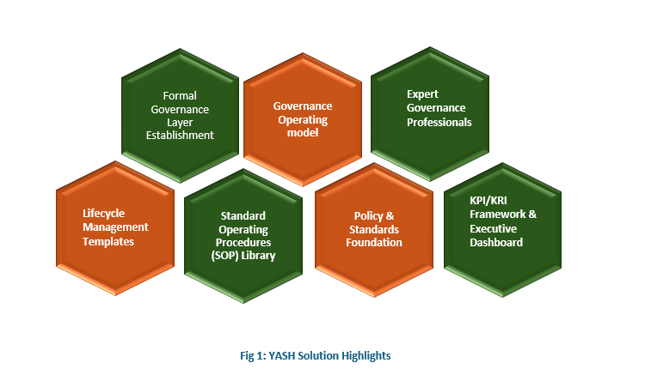

- Formal Governance Layer Establishment: YASH establishes a comprehensive cybersecurity governance framework that creates a policy-driven foundation aligned with NIST CSF 2.0 and organizational context.
- Policy & Standards Foundation: Through creation and alignment of formal policy sets, technical standards, and operating procedures, YASH ensures your organization operates within a cohesive, standards-based governance model that meets regulatory requirements and industry best practices.
- Standard Operating Procedures (SOP) Library: YASH authors a comprehensive SOP library that defines execution methodology and measurement criteria, providing your teams with clear, documented processes that drive consistent implementation and measurable control effectiveness.
- Governance Operating Model: We establish a structured governance cadence through charter definition, role clarification, and formalized meetings, ensuring consistent oversight, stakeholder alignment, and executive engagement at appropriate decision-making intervals.
- KPI/KRI Framework & Executive Dashboard: YASH designs and implements a tailored KPI/KRI framework with a pilot executive dashboard, delivering real-time visibility into governance effectiveness, compliance posture, and control performance—enabling data-driven decision-making at the leadership level.
- Lifecycle Management Templates: We provide standardized lifecycle templates for policies, standards, SOPs, exceptions, and risk acceptance, ensuring governance artifacts follow consistent quality standards and enable scalable, repeatable governance processes.
- Expert Governance Professionals: Our dedicated teams comprise cybersecurity governance, risk and compliance professionals with deep expertise in policy development, compliance frameworks, risk management, and executive reporting, ensuring the engagement meets the highest governance standards.

Scope of Engagement

In-Scope
- Create/update policy set aligned to NIST CSF 2.0 and MFO context.
- Author supporting technical standards and baseline configurations.
- Produce an SOP library defining execution and measurement.
- Document a governance operating model (charter, roles, cadence).
- Define KPI/KRI framework and implement a pilot executive dashboard.
- Publish lifecycle templates: policy, standard, SOP, exception, risk acceptance.

Out of scope
- No configuration, implementation, tuning, or hands-on use of any security tools or platforms.
- No execution of operational activities (vulnerability scans, patching, firewall changes, DLP alert investigation, BCDR tests, etc.).
- No enterprise-wide rollout or adoption activities beyond the pilot governance meetings.
- Dashboard work limited to an Excel/PowerPoint pilot for current scope, advanced BI or automation can be taken up as a separate project post pilot if needed.

Key Assumptions
- This proposal is estimated based on the scope provided by MFO​
- MFO will provide access to all necessary data and information to develop the needed policies, procedures and standards
- MFO will provide access to existing policies, risk registers, and KPI data sources.
- One review cycle per deliverable with up to one round of consolidated feedback is considered.
- Significant re-writes or multiple review cycles beyond the agreed process may be treated as scope change.
- Delays due to external entities shall not be attributed to the YASH project plan​
- The YASH team is not responsible for internal communication, coordination, or scheduling with internal stakeholders; this will be managed by the MFO SPOC​​
- Any additional changes to the work order would require a review of delivery timelines, cost implications, and building consensus collaboratively​.
- Dashboard pilot will be Excel or PowerPoint based, with no additional tooling or integrations.
- Project execution is considered fully offshore and will be executed from the YASH Offshore Development Center (India).

Pre-requisites
- A phone number where a client contact may be reached​
- Any special instructions we need to be aware of​
- MFO will provide the required logical access for YASH team assigned to this engagement. ​
- MFO will assign a dedicated SPOC (Project Coordinator) who will act as the single point of contact for YASH throughout the project​

Service Delivery Model
YASH will use a streamlined, shared-services delivery model designed to ensure efficient execution, consistent coordination, and strong governance oversight throughout the engagement. Under this model, YASH provides an integrated GRC team that collaboratively develops all policies, technical standards, SOPs, governance components, and reporting elements in a structured, documentation-led manner aligned to NIST CSF 2.0.
The team works as an extension of MFO’s cybersecurity governance function, driving workshops, managing document development cycles, and ensuring quality and alignment across all governance artifacts. Delivery is fully remote, primarily tool-agnostic, a minimizing operational impact on MFO while maintaining transparency through coordinated stakeholder engagement and regular progress reporting.
This approach ensures that governance documentation is developed consistently, efficiently, and with clear oversight—supporting MFO’s long-term cybersecurity governance maturity objectives.

Project Team Structure
S. No | Roles as per MFO | YASH Proposed Roles
1 | Governance Lead | GRC Specialist
2 | Policy Analyst | GRC Consultant
3 | Standards Engineer | GRC Consultant
4 | SOP Writer | GRC Analyst
5 | Data Analyst | GRC Analyst

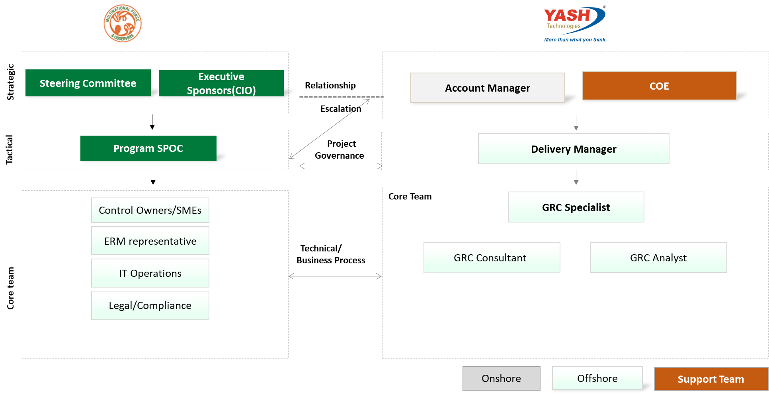
Table 3: Roles and Responsibilities
S. No | Role | Key Responsibilities
1 | GRC Specialist | Provide overall governance direction and alignment with NIST CSF 2.0.  Offer senior advisory and quality oversight for all deliverables.  Support escalations, risk mitigation, and high-level stakeholder engagement.  Ensure consistency and governance integrity across policies, standards, and SOPs.
2 | GRC Consultant | Coordinate and track day-to-day project activities, deliverables, timelines, and reviews.  Lead workshops, stakeholder discussions, and requirement clarification.  Develop and refine all policies, technical standards, and governance documentation.  Ensure alignment to CIS/NIST/vendor best practices and maintain document consistency.
3 | GRC Analyst | Support coordination, documentation tracking, versioning, and meeting notes.  Assist in developing SOPs, metrics, dashboards, and evidence requirements.  Prepare templates, structure content, and ensure accuracy of documentation.  Collaborate with SMEs to incorporate process details and maintain workflow clarity.

Approach and Methodology
YASH will adopt a structured, phased approach to develop a complete cybersecurity governance documentation bundle aligned to NIST CSF 2.0 and MFO’s operating environment. Delivery will be remote and executed through YASH’s GRC consulting team using a tool-agnostic, documentation-focused methodology.
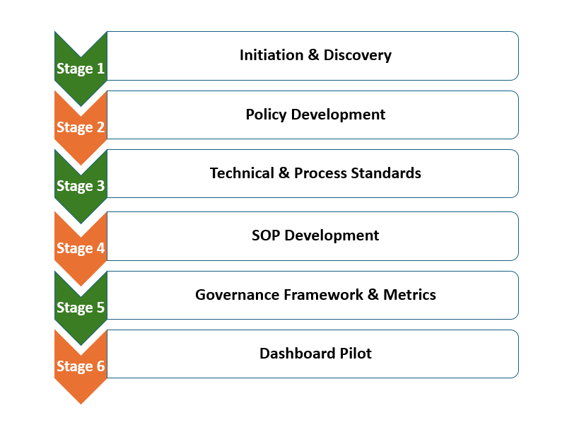

Stage 1 – Initiation & Discovery
Kickoff, planning, review of existing artifacts, SME workshops, confirmation of templates, and finalization of the document structure and requirements.
Stage 2 – Policy Development
Creation and update of organization-wide and branch-level policies using a standardized policy framework, aligned to NIST CSF 2.0 and MFO’s governance context.
Stage 3 – Technical & Process Standards
Development of technical and process standards that establish configuration and control baselines, aligned to industry recommendations (e.g., CIS Benchmarks, NIST guidance, vendor best practices) and mapped to NIST CSF requirements.
Stage 4 – SOP Development
Drafting of detailed, tool-agnostic SOPs that help operationalize both the policies and the technical standards, defining process steps, evidence requirements, metrics, and NIST mappings across key security domains.
Stage 5 – Governance Framework & Metrics
Definition of the governance operating model, RACI, lifecycle workflows, and a KPI/KRI framework to support ongoing oversight and performance measurement.
Stage 6 – Dashboard Pilot
Design and delivery of an excel or PowerPoint dashboard templates along with the dashboard refresh SOP to support periodic reporting.

This phased methodology ensures structured execution, consistent quality, alignment to security best practices, and maintainability of documentation regardless of future technology changes.

Key Deliverables

Deliverables
Below are the key deliverables for this engagement:
Table 4: Key Deliverables
Category | Deliverable
Cybersecurity Policy Set | Organization-Level
 | Information Security Policy (master; governance, roles, exceptions).
 | Acceptable Use Policy
 | Identity & Access Management (IAM) Policy (JML, MFA).
 | Privileged Access Management (PAM) Policy.
 | Incident Response Policy
 | Third-Party Risk Management (TPRM) Policy
 | Business Continuity & Disaster Recovery (BCDR) Policy
 | Cloud Security Policy
 | Branch-Level
 | Risk Management Policy (ERM integration; scoring; treatments).
 | Access Control Policy (RBAC, least privilege, reviews).
 | Change Management Policy.
 | Vulnerability & Patch Management Policy.
 | Security Monitoring & Logging Policy.
 | Data Loss Prevention (DLP) Policy.
 | Cryptography & Key Management Policy (incl. TLS
 | Network Security Policy
 | Asset Management Policy.
 | Backup & Restore Policy.
 | Secure Development / SDLC Policy (if applicable) – note the MFO does limited
 | development activities restricted typically to the SharePoint and SAP environments
Technical & Process Standards | Password & Authentication Standard.
 | TLS Configuration Standard (TLS 1.2+; ciphers; certificates).
 | Firewall & Network Hardening Standard.
 | Endpoint Security Standard.
 | Server & OS Hardening Standard.
 | Logging & Retention Standard.
 | Vulnerability Scanning Standard (credentialed; severity mapping).
 | Patch Deployment Standard
 | Data Classification & Labelling Standard.
 | DLP Policy Rule Standard (email/endpoint/web/cloud).
 | Access Review Standard (frequency; evidence).
 | Third-Party Assessment Standard.
 | Backup & Restore Standard (immutability; restore testing).
 | Segmentation & Remote Access Standard (VPN; bastions).
 | Change Management Standard (CAB; rollback).
Standard Operating Procedure (SOP) Library | Policy Lifecycle SOP – drafting, review/approval, publishing, exceptions, renewal.
 | Risk Identification & Assessment SOP – intake, scoring, treatments, register updates.
 | KPI/KRI Collection & Dashboard Refresh SOP – data pulls, validation, sign-off, publishing.
 | Change Management SOP – request → impact → approve → implement → PIR.
 | Excel or PowerPoint–based executive cybersecurity dashboard template covering KPIs/KRIs, risk posture and governance metrics
 | Incident Handling SOP – triage, containment, comms, evidence, closure.
 | Regulatory Reporting SOP – triggers, timelines, templates, approvers.
 | Vulnerability Scanning SOP – scope, credentials, scanning, validation, ticketing.
 | Patch Management SOP – packaging, testing, deployment, back-out.
 | Access Provisioning/Deprovisioning SOP – JML, SoD, approvals, logging.
 | Quarterly Access Review SOP – sampling, attestation, remediation, evidence.
 | TPRM Assessment SOP – tiering, questionnaires, follow-ups, remediation.
 | DLP Incident Triage SOP – alert review, classification, user engagement, tuning.
 | Asset Onboarding/Offboarding SOP – CI creation, ownership mapping, reconciliation.
 | Firewall Rule Review SOP – export, analysis, risk ranking, approvals, change.
 | TLS Deployment SOP – inventory, cert lifecycle, config rollout & validation.
 | Backup Validation & Restore Test SOP – sampling, test runs, evidence.
 | BCDR Exercise SOP – scenario design, execution, AAR tracking.
 | Exception & Risk Acceptance SOP – request, compensating controls, expiry.
 | Awareness Campaign SOP – schedule, scenarios, metrics, reinforcement.

Project Management and Governance

Project Governance and Reporting
YASH follows a structured governance, reporting, and escalation process that leverages the shared leadership model from MFO and YASH. To provide better service to MFO, YASH will put in place a structured governance model that will enable agreed targets, prompt progress reporting, handle exceptions, manage risks, and realize benefits. YASH’s Delivery Manager collates and uploads the regular status reports into SharePoint team collaboration sites or sets up a project schedule list for overall status tracking. This information and the analysis will be summarized into an overall status report. These reports will then be compiled into a sponsor status report for MFO, and the following checkpoint reports are proposed to ensure that all activities are planned, executed, monitored, and controlled appropriately:
The image below depicts the multi-tier governance, reporting, and escalation structure that we propose for these implementation services:
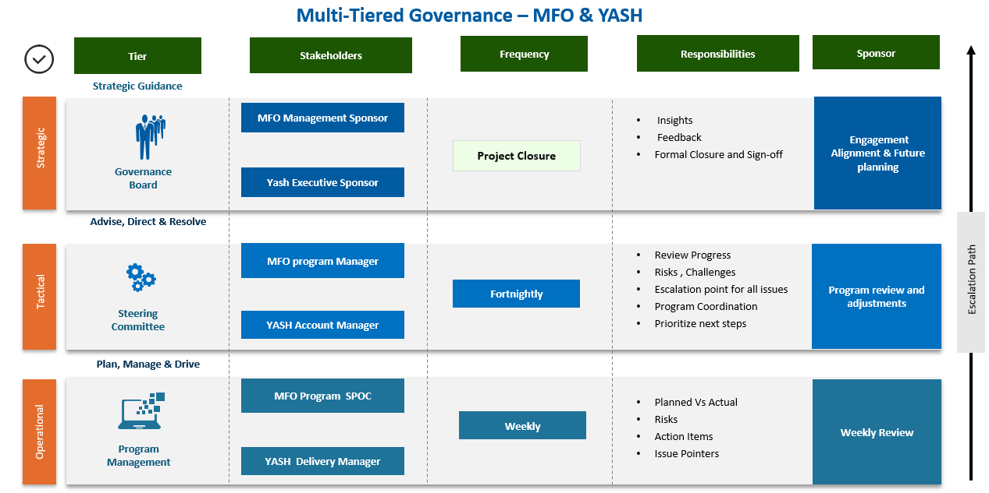

Communication Process
To ensure tightly coupled coordination, which is required for the successful execution of this project, all parties involved must commit to an efficient and effective project communication process. This includes identifying issues, resolution of issues, obtaining decisions, getting approvals, and defect fixes on time.
Specific details of this can be worked through mutual discussions between YASH and the MFO, but YASH recommends the following communication plan:
Tools | Functions
Virtual Meetings | Microsoft Teams will be used for web meetings and presentations
Group Email ID | Communication of incoming work requests and correspondence

Escalation Management
Most issues encountered during the duration of the engagement are easily resolved. Occasionally, a serious issue is encountered that, if left unresolved, could interrupt business. In the shared interest of keeping the services on track, issues must be managed well and receive timely management attention and decision-making. It is also essential that the MFO team and YASH team take equal responsibility for issue management and work together to resolve issues.
For any issues that do not get addressed within the agreed time frame, the following escalation path is followed:
Level | YASH Contact | MFO Contact
Level 1 | Delivery Manager | Program SPOC
Level 2 | Account Manager | Executive Sponsor

Change Management
The scope of work as specified in this proposal shall not change except where approved using the following process:
- The YASH Delivery Manager reviews an issue and determines that the resolution will lead to a change in scope, defined as a change that will impact cost, schedule, or staffing
- The proposed change is documented in a scope change order, including the impact on schedule, cost, and staffing
- The scope change order is reviewed by the project's scope change board and approved by signing the change order
- At this point, the change order becomes an addendum to this proposal
It is proposed that the members of the scope change board be comprised of the MFO Steering Committee, MFO Project Manager, and YASH Delivery manager, with full responsibility and authority to review and approve changes to this proposal.

Case Studies

Leading UK Railway Technology Provider
YASH Technologies partnered with a leading UK railway technology provider to achieve rapid cybersecurity compliance and ISO 27001:2022 readiness. Through a Business Context Workshop and governance-led approach, YASH aligned the client with UK’s National Cyber Security Centre (NCSC) guidelines, ISO 27001 standards, and delivered 40+ security documentation including policies, SOPs, guidelines and templates. The engagement enabled certification readiness, boosted vendor credibility, and strengthened competitiveness in critical infrastructure projects.
Client | Leading UK railway technology provider
Challenges | - Stringent compliance requirements as a critical vendor to the UK government railways  - Needed alignment with NCSC guidelines and ISO 27001:2022 certification requirements  - Limited existing documentation and faced certification timelines
Solution Highlights | - Comprehensive Business Context workshop to understand railway operations, regulatory obligations, and organizational structure  - NCSC Guidelines alignment ensuring compliance with UK government cybersecurity standards  - ISO 27001:2022 framework implementation tailored to railway technology sector requirements  - Created 40+ policies, SOPs, guidelines, and templates  - Accelerated delivery methodology to meet ISO certification audit timelines
Business Benefits | - Achieved ISO 27001:2022 certification readiness with a comprehensive governance framework  - 40+ governance documents created and approved, establishing a robust security posture  - Enhanced vendor credibility and competitive positioning for critical infrastructure projects

Leading Healthcare company
YASH Technologies helped a leading healthcare company improve its cybersecurity posture by conducting a NIST-based assessment, implementing 24x7 security monitoring, and managing a SIEM solution with over 100 custom threat signatures. Through automated incident response, threat hunting, and governance-led execution, YASH reduced the client’s attack surface by up to 80%, accelerated incident resolution to under 15 minutes, and drove year-over-year improvements in NIST maturity and business risk reduction.
Client | Leading Healthcare Company
Challenges | - Low NIST maturity  - Cloud adoption in a rapid manner; Data access demands from remote endpoints  - Poor attack surface management leading to non-compliance and many alerts
Solution Highlights | - NIST Based Assessment and security roadmap, along with program governance  - 24*7 security alert monitoring  - SIEM solution management configured with 100+ signatures to address modern-day attacks e.g., Ransomware  - Threat hunting, Playbook-driven modern threat response & automated incident response
Business Benefits | - Increase NIST score YOY and enhanced cyber security posture  - Decreased attack surface up to 85%  - Reduce- business and organizational risk up to 80%  - Expert support and rapid incident investigations & response in <15mins  - Unrivalled accuracy to quickly detect and shut down real attacks

Indicative Profiles

Name | Role | Professional Summary
Mahipal Kirupanithy | Sr. GRC Consultant | - 25+ years of experience in IT, Cyber Security, and GRC with expertise in enterprise CISO organizations, security consultancy, and cloud security assessment programs.  - Extensive experience working with leading global IT organizations including Mindtree, HCL, and Marlabs Innovation in senior leadership roles.  - Proven track record in handling security practice business and delivering key security assignments successfully across financial services, IT Services, Automotive, Aerospace, Manufacturing, and Healthcare sectors.  - Strong expertise in CISO advisory services, industry and business-aligned security program development, and stakeholder management.  - Led Mindtree's Cloud Practice to obtain Microsoft's Azure Expert Managed Services Provider (MSP) certification as domain owner for security and governance.  - Successfully managed ISO 27001 certification transition from 2005 to 2013 version across pan-India and global delivery centres.  - Certified professional holding SABSA Architect (SCF), CIPP/US, CISA, CISM (Qualified), ISO 27001 Lead Auditor, ISO 22301 Lead Auditor, and MCSE-Security certifications.  - Expertise in frameworks including ISO 27001, SSAE18/ISAE3402 SOC 1/SOC 2, PCI-DSS, NIST CSF, CSA CCM, Data Privacy, and Business Resilience.  - Experience in building cloud security frameworks, data security frameworks, cyber security maturity models, and automated continuous control monitoring services.
Vasanth Kumar N | GRC Consultant | - 11+ years of experience in Information Security Domain with expertise in compliance, risk management, and security operations.  - Extensive experience across multiple frameworks including ISO 27001:2013, HIPAA, HITRUST, SOC 2/1, and GDPR.  - Strong expertise in ISMS Management, aligning security policies with regulatory standards, defined security policies, developing and maintained Standard Operating Procedures (SOPs), and ensured consistent implementation of IT security controls across the enterprise.  - Proven track record in ISMS implementation, audit management, and incident response across diverse organizations including IBM, Cognizant, Optiv Security, and Qatar Computer Service.  - Strong background in Third-Party Audits, Internal Audits, and Regulatory Compliance with experience in conducting privacy risk assessments and gap analysis.  - Expertise in Identity and Access Management (IAM) using IBM Tivoli Identity Manager and COURION Manager.  - Certified professional holding CISM, ISO/IEC 27001:2013, CRISC, CEH V9.0, CCNA, CompTIA Security+ , ITIL v3.0 Foundation certifications.  - Experience in Business Continuity Planning (BCP), Disaster Recovery (DR), and Security Operations Center (SOC) management.  - Skilled in conducting security awareness training programs and policy alignment with regulatory standards.
Sagar Gedam | GRC Analyst | - 6+ years of experience in GRC, TPRM, ISMS internal audits, and implementation with strong focus on ISO 27001 and NIST frameworks.  - Spearheaded ISMS implementation for multiple clients, leading to successful ISO 27001 certification, and achieving a 100% compliance rate across all assessed controls.  - Orchestrated and led the team for development and deployment of an ISMS, achieving compliance with ISO 27001 and enhancing security best practices  - Teamed with cross-functional teams to develop risk mitigation strategies and enhance vendor management processes.  - Experience in conducting comprehensive ISMS internal audits and risk assessments across financial, power, defense, and manufacturing sectors.  - Certified ISO 27001:2022 Lead Auditor, ISO 22301 BCMS Lead Auditor, ISO 20000 ITSM Lead Auditor, and ISO 27001:2013 Lead Auditor  - Skilled in vulnerability management, incident management, and security training & awareness programs.

Corporate Overview

YASH Overview and Relevant Capabilities

YASH Overview
YASH is a leading Global IT service provider with 30 years of experience, having strong presence across diverse services like Application, Infrastructure and IT support, Consulting, Technology, and Outsourcing. With forty-three (44) Global delivery centers across six (6) continents and a team of 9000+ employees we proudly maintain one of the lowest attrition rates catering to diverse industries. We are “Partner of choice” for 450+ large enterprise and midsize customers. Our have strong and mature alliances with leading technology and solution providers like Microsoft, SAP, Oracle, Worksoft, and IBM, and more emphasize our commitment to delivering top-tier solutions.
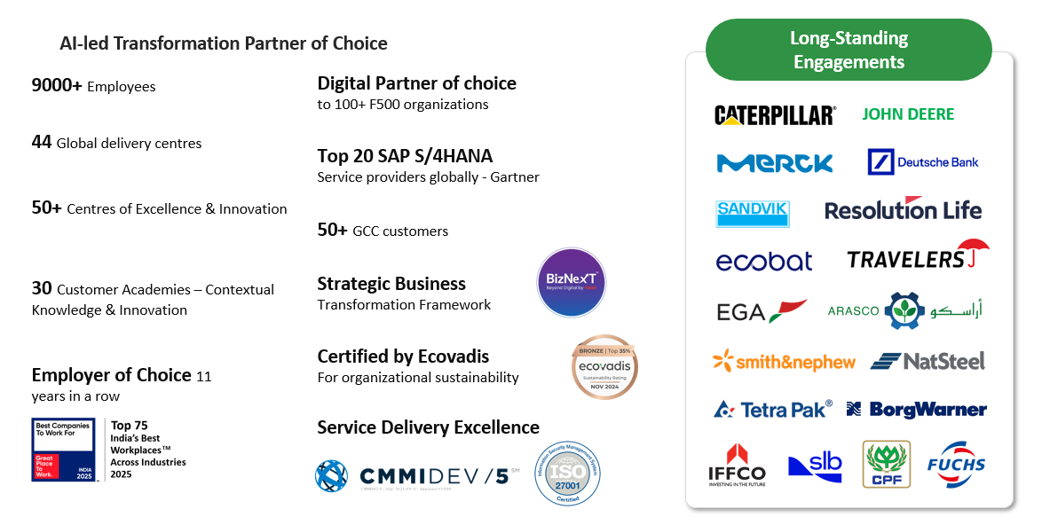
- YASH has global headquarters in East Moline, Illinois, USA, with forty-four (44) Global delivery centers spread across six (6) continents.
- We make a revenue of around $ 425 Mn, financially sound, profitable, and debt-free organization.
- Our ability to invest in competencies, assets, and relationships helped us to maintain long-term relationships with our customers.
- Our strategic acquisitions of structured companies with a strong regional (UAE and UK) and vertical focus strengthened our services globally across domains such as Manufacturing, Heaving Machinery and Equipment, Healthcare and Life sciences, Chemical, BFSI (Banking, Financial Services, and Insurance), and Oil and Gas
- We have been recognized as “Great Place to Work” for ten consecutive years from 2015 to 2025.
- We deliver a full suite of enterprise IT services including Application Maintenance Services, Infrastructure Maintenance Services, Application Development, Implementations, Upgrades, Migrations, And Strategic Consulting. Our Service Portfolio includes Digital Services, Packaged and Custom Applications, Infrastructure Management Services, Cloud Transformation Services, Quality, and Testing Services
- Customer Satisfaction, Revenue Growth, and Innovation are the strategic focus areas of YASH.

YASH Global Footprint
YASH has global headquarters in East Moline, Illinois, USA, with forty-four (44) Global delivery centers spread across six (6) continents. We possess required infrastructure and capabilities in all our delivery centers.
Our Delivery Centers and Sales Offices are located globally and listed below:
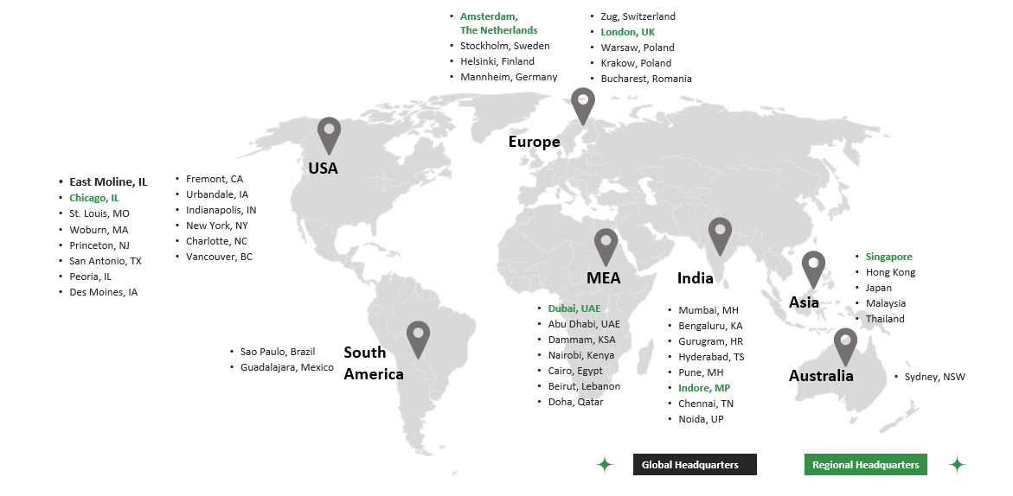

Service Catalog
Leveraging our Vertical COEs, Horizontal COEs, strong relationships and alliances with leading technology providers, subject matter experts, and a strong program management framework, YASH delivers a wide range of services including end-to-end implementation, upgrades, rollouts, migrations, enhancements, custom developments, integration, infrastructure services across solutions/technologies.
The below snapshot gives an overview of our service lines designed to cater to a wide range of our customers’ needs. We are distinctively placed to be able to deliver to MFO requirements today and in the future.
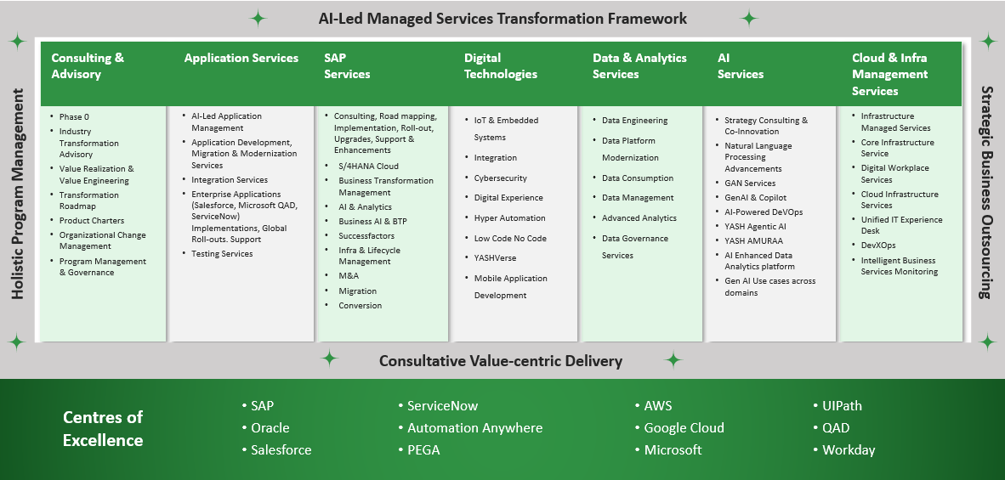

YASH Recognitions and Awards
Following is a list of the industry recognitions and awards YASH has received over the years:
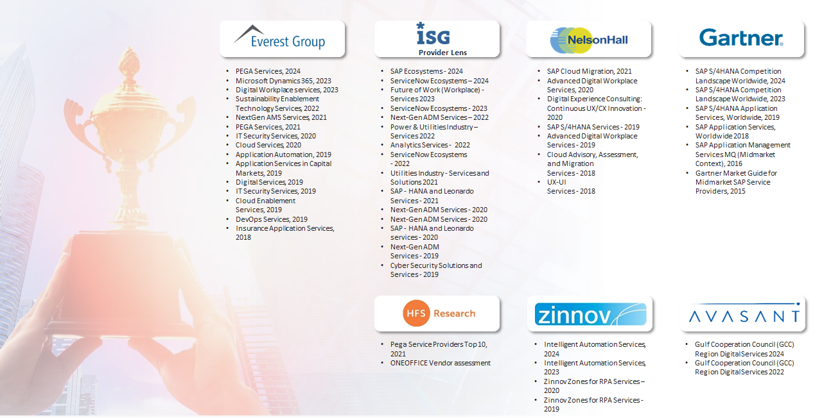

Overview of Partnership and Alliances
Below is a snapshot of YASH strategic partnerships and alliances with many companies:
YASH partnerships:
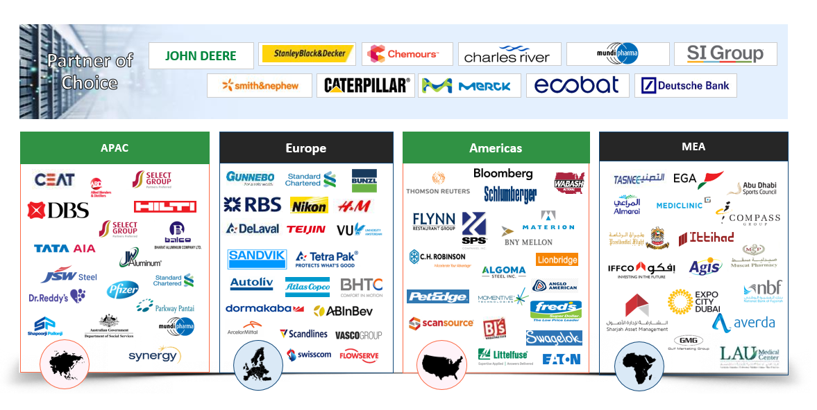

Relevant Industry Certifications

S. No | Certification | Description | Certification
1 | SOC 1 Type II | YASH is attested with SOC 1 Type II, demonstrating that its internal controls over financial reporting are not only well-designed but also consistently operated and effective over time.
2 | CMMI Dev v2.0 Level 5 | Our delivery excellence, the maturity of processes, and the quality of software development & services are appraised for CMMI Dev V2.0 Level 5
3 | ISO 27001:2022 | YASH is attested for ISO 27001:2022, an endorsement of our continued compliance with the highest standards of information security management system
4 | ISO 9001:2015 | Our ISO 9001:2015 attestation is an assurance for our products and services, effective delivery excellence in compliance with customer and applicable statutory and regulatory requirements




2025 YASH Technologies | www.YASH.com | Confidential

Important Notice: This document and any attachments submitted with it are confidential and intended solely for the use of the individual or entity to which it is addressed. If you are not the intended recipient, you are hereby notified that dissemination, forwarding, printing, copying or any other use of this document, any attached documents, and the information these documents contain, is strictly prohibited. If you have received this by mistake, please advise the sender immediately and destroy/invalidate the document.

